**Silicone Embossing Machine**

1. **Product Introduction**

It is used for all kinds of fabric embossing plant glue, leather embossing, garment embossing, color changing leather, multi-color silicone cup holder, trademark leather branding, liquid silicone trademark production, etc.

1. **Product Parameter**

Model:YC290330 Power:380v/18kw

Heating plate size:300*400mm Pressure:650kg

Dimension:1850*1810*1900mm

1. **Product Feature**
2. Hydraulically powered, independently controlled double head, aluminum sliding table.
3. The hydraulic pressure is adjustable, and the automatic sliding table controls the molding of the product.
4. The molding time can be adjusted arbitrarily.
5. Forming time can be adjusted arbitrarily.
6. intelligent temperature control, so that the set temperature and the actual temperature difference between plus and minus 1 degree.
7. The travel limit adjuster, according to the pressure of the material, the thickness of the mold to adjust.
8. **Machine Details**

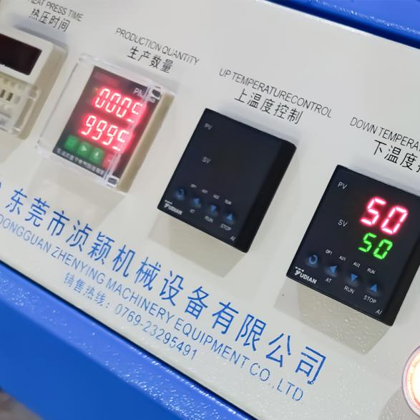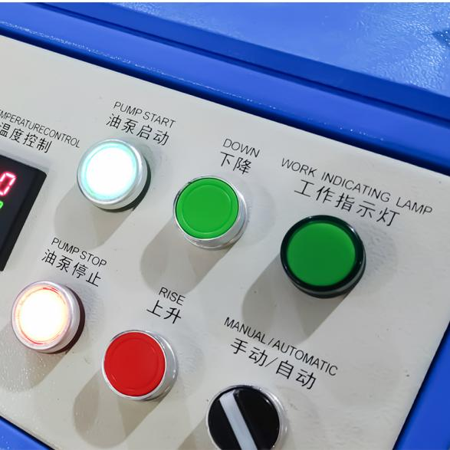

1. **Product Display**

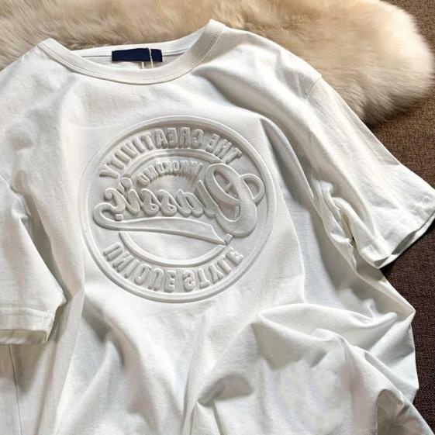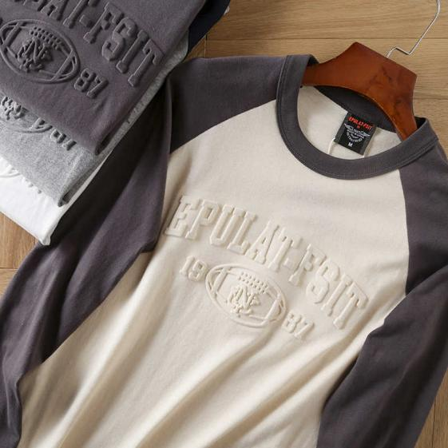

1. **Product Qualification**

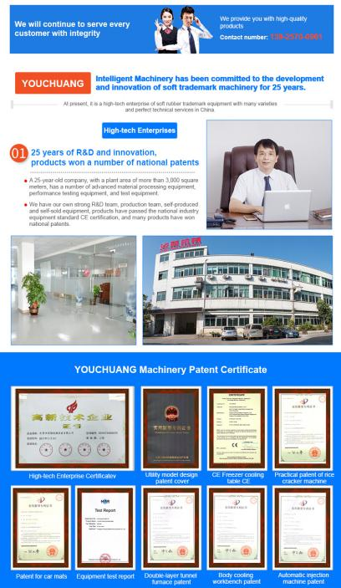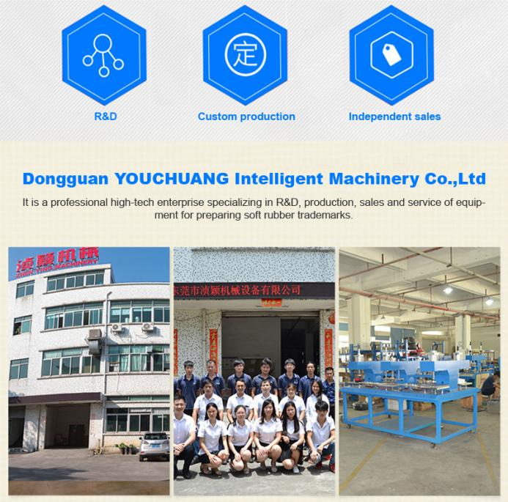

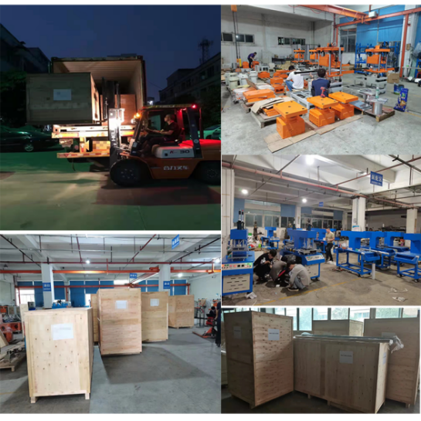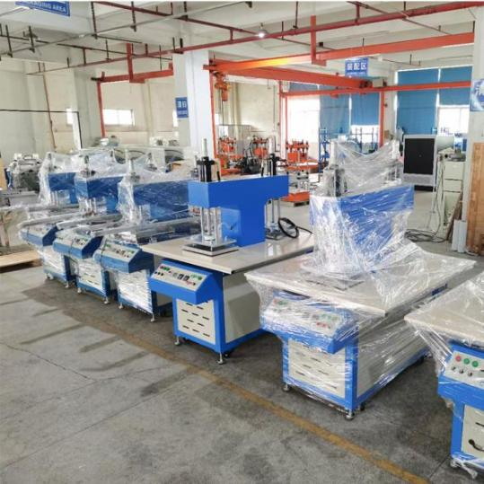

1. **Deliver,Shaping and Serving**

****Pre-install service:****  
1)Inquiry and consulting support.

2)Sample testing support.

3)View our Factory.

****After-sale service:****  
1)Training on how to install the machine, training on how to use the machine.

2)Engineers available to service machinery overseas.

1. **FAQ**

A: Are you a factory? How many workers do you have?

B: Yes, we are a factory. Our factory is located in Dongguan, Guangdong. We have about 30 workers in our factory.

A: How about after-sales service?

B: 12 months for the electrical part and 18 months for the mechanical part after the machine is installed and running normally.

A: What about the installation?

B: Our engineers can be sent to your country, but the customer shall pay for the air tickets, in addition, the customer shall arrange their accommodation during the journey.

A: What should we do if we have a problem about the machine?

B: Show us the picture or video of the problem. If it is a problem with a small machine, we will send you the solution via video. If it is a problem with a large machine, our engineer will go to your factory (the customer will pay for the trip).

A: How do you control the quality and delivery?

B: All our machines are tested before packing, wooden packing is strong and safe for long term transportation.